REPORT
OF JOB SHADOWING WEEK AT UNIVERSITY OF GRANADA, 3-7 SEPTEMBER, 2018.
Project UZDOC 2.0 .: “Furthering the quality of doctoral education at Higher Education Institutions in Uzbekistan”

According the program of project UZDOC 2.0. “Furthering the quality of doctoral education at Higher Education Institutions in Uzbekistan” I have participated as Contact person from Tashkent Chemical-Technological Institute in Job shadowing week organized at the University of Granada on 3-7 September, 2018.
It was 13 representatives from the Uzbekistan partner Universities: Tashkent Financial Institute, Karakalpak State University, Karshi State University, Namangan State University, Samarkand Institute of Economics and Service, State Institute of Arts and Culture of Uzbekistan.
During 5 day of training seminar we have studied tha structure of University of Granada, get knowledge about 3 Doctoral schools in UGR, 27 faculties, 123 departments, 16 research institutes, 4 research centers and 400 research groups. Comparing Uzbek Universities we have noticed that UGR is big University with 61 000 students. According international ranking UGR is on 300th place and it is on second place between Spain Universities.

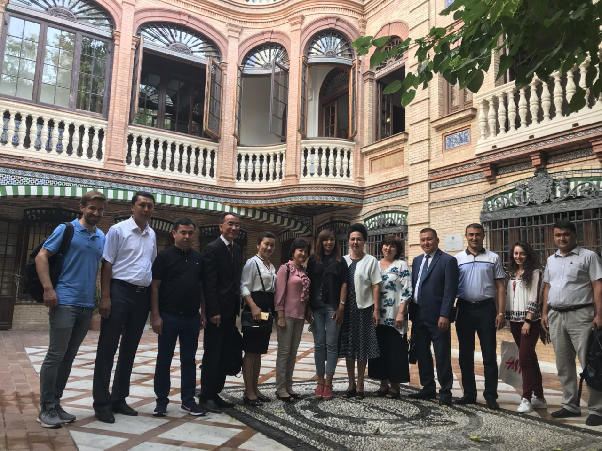
Participants of Job Shadowing week in University of Granada, 03.09.2018.

TCTI team have visited Departments of “Inorganic Chemistry”, “Analytical Chemistry” and “Physical Chemistry” at the Faculty of Fundamental and Social Sciences at the University of Granada in Spain. During this visit laboratory equipment was studied, as well as methods training of specialists. In addition to the above, participants was also introduced to the library of the University of Granada and examined existing educational, scientific and other types of literature.
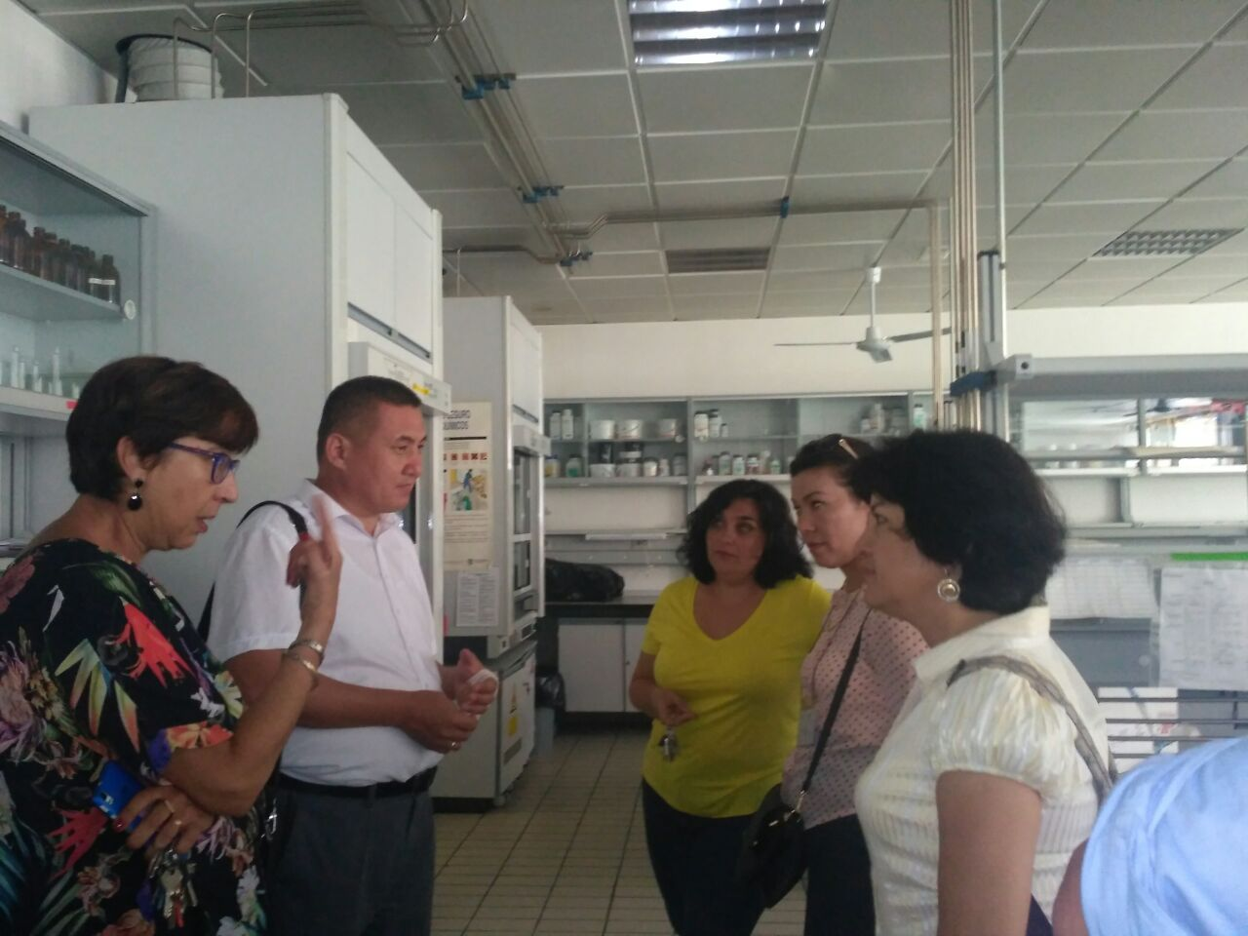
Visit to Department of “Physical Chemistry” at the Faculty of Fundamental and Social Sciences, University of Granada, 05.09.2018.

Experience of the University of Granada will be implemented during teaching of these subjects in Tashkent Chemical-Technological Institute. I have learned about Strategic management and Internationalosation strategy in UGR. These issues are very important for all Uzbek Universities. I will implement acquinted knowledge to futher development of structure of our institute.
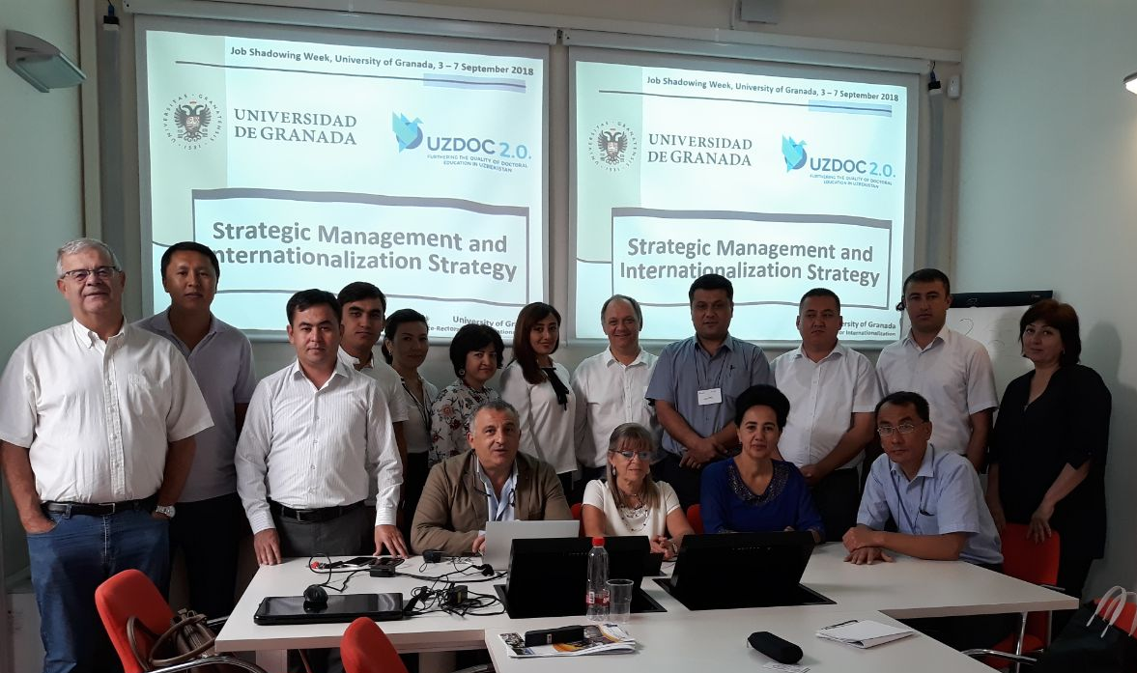
Good example of work was introduced by Doctoral council of UGR. We have no such structure in TCTI, I think it would be helpful if we develop this structure in our institute.

Written by:
Head of International Relation Department of Tashkent Chemical-Technological Institute, Contact person for UzDOC2.0 project in TCTI Zebo Babakhanova

