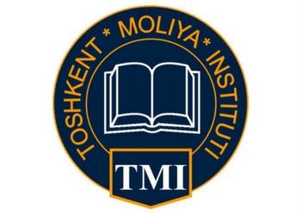
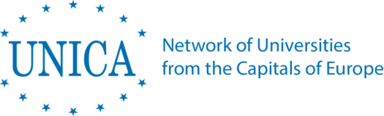

UZDOC 2.0. project
University-business-industry cooperation in doctoral education: Perspectives from Europe and Uzbekistan

Roundtable with business & industry representatives from Uzbekistan

Tashkent (Tashkent Institute of Finance)
Tuesday, 2 October 2018
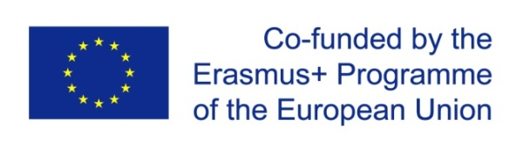 | UZDOC 2.0.: Furthering the quality of doctoral education at Higher Education Institutions in Uzbekistan  573703-EPP-1-2016-1-BE-EPPKA2-CBHE-SP (2016-3796)

Programme version as of 30 September 2019 (V.1)

Venue: | Tashkent Institute of Finance
Address: | - 60A Amir Temur Street, Tashkent, Uzbekistan
Reference point: | - MINOR Subway station

Programme

Language of the meeting: English, whispered English to Uzbek translation
Chair of the day:
Jasur KARIMKULOV, Vice-Rector for Science at Tashkent Financial Institute, Local Coordinator of UZDOC 2.0. project

Tuesday, 2 October
08:30-09:00  09:00-09:30 | Registration of participants  Welcome  - Welcome by Mr. Ulugbek Azizov, Rector, Tashkent Financial Institute  - Welcome by Welcome by Mr Jussi NARVI, Head of Political, Press and Information Section Delegation of the European Union to Uzbekistan  - Welcome by Mrs Aziza Abdurakhmanova, Head of National Erasmus+ Office in Uzbekistan  - Welcome and objectives by Mrs Kris Dejonckheere, UNICA Secretary General & UZDOC 2.0. Project Coordinator
09:30-10:15 | OPENING SESSION  Setting the context: University-business-industry cooperation in doctoral education: Perspectives from Europe and Uzbekistan  - Ibrokhim Yulchievich Abdurakhmonov, Ministry of Innovative Development  - Uzokboi Shoimkulovich Begimkulov, Vice-Minister of Higher and Secondary Specialised Education of the Republic of Uzbekistan  - Collaborative doctoral education in Europe: Partnerships for research, innovation, and career development of doctoral candidates - general presentation by Prof. Flavio CANAVERO, Professor in Electrical Engineering and former Director of POLITO Doctoral School, Polytechnic University in Turin  - Recap on the Turin UZDOC 2.0. Knowledge-sharing event: Common challenges and key takeaways by Claudia GIORDANO, PhD Officer at the Doctoral School of Polytechnic University of Turin and Pulatkhon LUTFULLAYEV, Head of International Relations, Namangan State University  - How to deal with University-Industry Relations and Doctorate Candidates by Patrick DI STEFANO, Industrial Relations Manager and Technology Transfer Expert, Université Libre de Bruxelles (ULB)  - Questions & Answers
10:15-10:30 | Time for a group photo
10:30-11:00 | Coffee break & networking
11:00-11:45  11:45-12:30 | ROUNDTABLE 1: What is the added value of university-business-industry cooperation in doctoral education? Needs, expectations, and potential benefits as seen by different actors  Chair: Zebo Babakhanova, Head of International Relations Office, Tashkent Chemical-Technological Institute  Introduction by Prof. Flavio CANAVERO, Professor in Electrical Engineering and former Director of POLITO Doctoral School, Polytechnic University in Turin  Discussion panel with the representatives of:  - Business/industry representatives from Uzbekistan  - Ministry of Higher and Secondary Specialized Education of the Republic of Uzbekistan  - Ministry of Innovative Development of the Republic of Uzbekistan  - Academic leaders from Uzbek partner universities  ROUNDTABLE 2: Laying ground for successful university-business-industry cooperation in doctoral education: How to make it happen? How to support doctoral candidates in their career development?  Chair: Pulatkhon LUTFULLAYEV, Head of International Relations, Namangan State University  Introduction by Prof. Flavio CANAVERO, Professor in Electrical Engineering and former Director of POLITO Doctoral School, Polytechnic University in Turin  Presentation on Career Preparation and Development for PhDs outside academia by Lisette Schmidt, Board Member of PRIDE: Association for Professionals in Doctoral Education / PhD coordinator, Center for Doctoral Studies, Research Services and Career Development, University of Vienna  Discussion panel with the representatives of:  - Business/industry representatives from Uzbekistan  - Academic leaders from Uzbek partner universities  - Doctoral candidates from Uzbek partner universities
12:30-12:45 | Wrapping up & Conclusions by Prof. Melita Kovačević, Professor at the University of Zagreb, former Vice-Rector for Research & Technology, Vice-President of the PRIDE Network, UZDOC 2.0. External Evaluator
12:45-14:15 | Lunch at Tashkent Financial Institute
14:15-14:45 | Transport to Turin Polytechnic University in Tashkent
14:45-15:05 | Turin Polytechnic University in Tashkent - presentation by Prof. Igor Stievano, Vice-Rector for Academic and Scientific Activity at Turin Polytechnic University in Tashkent, followed by Questions & Answers
15:05-16:45 | Visit to the Tashkent campus of the Polytechnic University of Turin
16:45-17:00 | Farewell words, wrapping up & key takeways by Prof. Melita Kovačević, Professor at the University of Zagreb, former Vice-Rector for Research & Technology, Vice-President of the PRIDE Network, UZDOC 2.0. External Evaluator

Wednesday, 3 October 2018
Departures of participants

